.
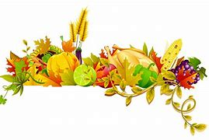 | November 2021 Breakfast
Sun. | Mon. | Tue. | Wed. | Thu. | Fri. | Sat.
 | 1 | 2 | 3 | 4 | 5 | 6
 | Blueberry Muffin | Yogurt and Granola | Mini Cinnamon Rolls | Supersized Cereal | Strawberry Mini Bagels
7 | 8 | 9 | 10 | 11 | 12 | 13
 | Assorted Breakfast Bars | Waffles | Sliced Banana Bread |  | Bagel and Cream Cheese
14 | 15 | 16 | 17 | 18 | 19 | 20
 | Blueberry Muffin | UBR Breakfast Round | Mini Cinnamon Rolls | Supersized Cereal | Strawberry Mini Bagels
21 | 22 | 23 | 24 | 25 | 26 | 27
 | Assorted Breakfast Bars | Mini Chocolate Chip Pancakes | Sliced Pumpkin Bread
28 | 29 | 30 | 1 | 2 | 3 | 4
 | Blueberry Muffin | Yogurt and Granola | Mini Cinnamon Rolls | Supersized Cereal | Strawberry Mini Bagels

All Breakfast meals include a choice of fresh fruit and milk: 1% white, non-fat chocolate or lactose free. Menu subject to change without notice. This institution is an equal opportunity provider and employer.

